Amar Dhaliwal Simon Module

LVL 0:

Play the Simon game in your group while taking note of the following game-play items:

1. What was your personal best score?

:11

1. What was the personal best score in your group?

:11

1. What makes it a good game?

:The ability to have a high score and try to beat it

1. In what ways is it similar to modern computer games?

:its similar because you push buttons

Play the Simon game in your group while taking note of the following technical items:

1. How do users input information into the game?

Pushing buttons

1. How does the game output feedback to the players?

Bilking lights and sounds

1. What are the game options for starting the game?

Party mode and signal player mode

1. What are the end conditions for stopping the game?

Pressing the wrong button

LVL 1:

Research the history of the Simon game, focusing on the following questions:

1. Who created Simon?

Ralph Baer

1. What previous game was it based on?

Atari touch me

1. What was the first game system?

Magnavox

1. What games did it have on it?

pong

In your group, discuss the following questions:

1. What is the oldest game system you have played on?

Original Xbox

1. How are old games different from current games?

One major thing is the graphics, before video games had really pixelated graphics and now video games graphics can pass for real life

1. How are old games similar to current games?

One this that is similar between old games and new games are controls while the gameplay may be entirely different, the controls are still mostly the same

Lvl 2:

List all of the user input objects and actions using a table similar to the one below.

|  |  |  |
| --- | --- | --- |
| green | push | Start party game |
| green | push | Step in pattern |
| red | Push | Start solo game |
| red | Push | Step in pattern |
| yellow | Push | Step in pattern |
| yellow | push | Step in pattern |
| blue | Push | Step in pattern |
| blue | push | Step in pattern |
|  |  |  |
|  |  |  |

List all of the user output objects and actions using a table similar to the one below.

|  |  |  |
| --- | --- | --- |
| **Green** | Flash | Indicates a step in the pattern |
| **Green** | Play tone | Indicates a step in the pattern |
| **Red** | Flash | Indicates a step in the pattern |
| **Red** | Play tone | Indicates a step in the pattern |
|  |  |  |
| **Yellow** | Flash | Indicates a step in the pattern |
| **Yellow** | Play tone | Indicates a step in the pattern |
| **Blue** | Flash | Indicates a step in the pattern |
| **Blue** | Play tone | Indicates a step in the pattern |
|  |  |  |

List all of the a ll of the ways that an input action results in an output action using a table similar to the one below

|  |  |  |
| --- | --- | --- |
| **Red button** | **Red light** | Flashes when button is pushed |
| **Blue button** | **Blue light** | Flashes when button is pushed |
| **Green button** | **Green light** | Flashes when button is pushed |
| **Blue Button** | **Blue light** | Flashes when button is pushed |
|  |  |  |
|  |  |  |
|  |  |  |
|  |  |  |

LVL 3:

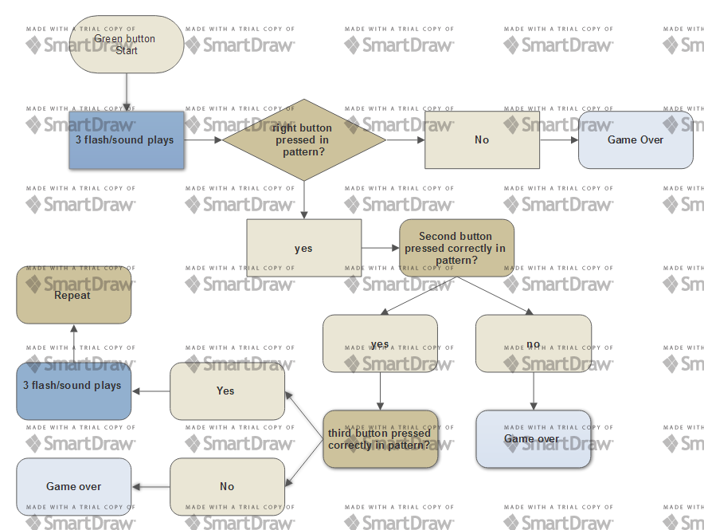

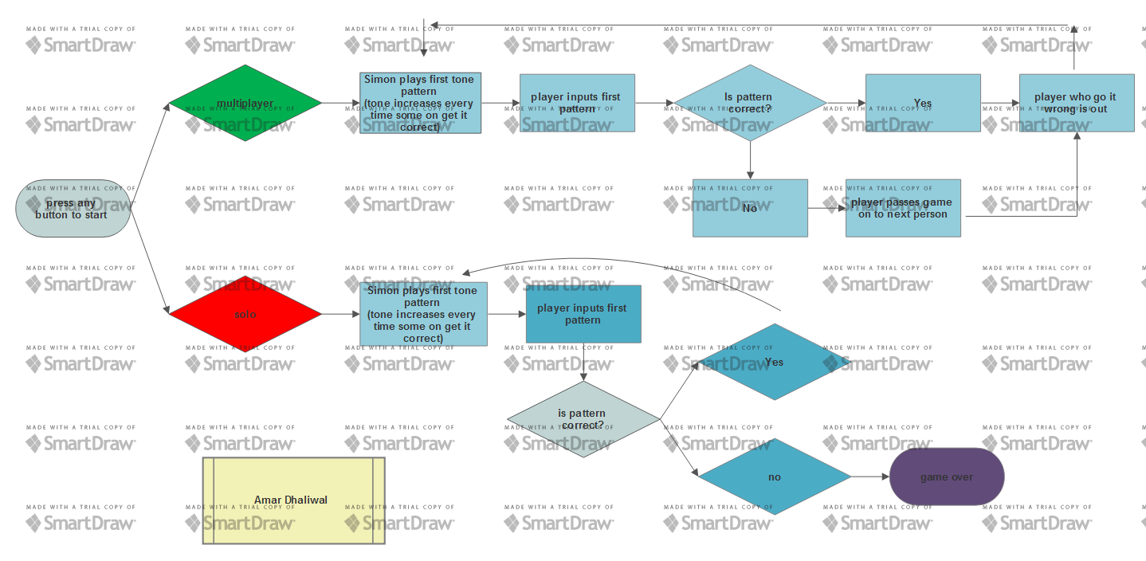LVL 4